What Is a Watershed & What Does It Have to Do with Me?
Have you ever been asked if you live in a watershed? Only to realize you aren’t sure, because you don’t really know what a watershed is. This is not uncommon. The term watershed is not historically well-known; however, it is starting to make its way into our conversations. Why? Let’s start with defining what a watershed is.
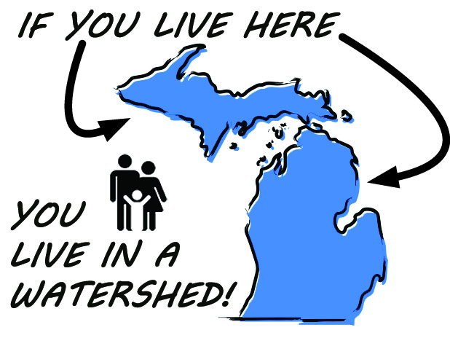
A watershed, also referred to as a drainage basin, is the land area that delivers rain and snow/ice melt to a stream or lake. Watersheds are divided by a ridge of high land which serves to separate two (or more) areas drained by different river systems. So, do you live in a watershed? Absolutely! Everyone who lives in Michigan, lives in a watershed!
So why is this important to know? No matter where you are at any given time, you are in a watershed, and your actions directly impact the health of that watershed. Additionally, the health of that watershed impacts you, everyone around you, and even the communities downstream.
When rain and snow/ice melt travel across the land (watershed) and through storm drains, it is called stormwater or runoff. As this runoff travels it picks up trash, contaminants, sediments and dissolved substances along the way until it discharges into the nearest water body. Small streams join to form rivers and flow across sloping land, eventually flowing into a lake. These bodies of water impacted by runoff provide recreational opportunities, habitat for wildlife, and even drinking water for communities. By keeping our cars from leaking, litter off the streets, and properly disposing of animal and chemical wastes we are being good stewards by protecting not only the health of our watershed but also ourselves and everything downstream.
To get more information on how you can protect water quality and to figure out which watershed you live and work in visit www.allianceofrougecommunities.com/watershed.html.

